**TH_QTVBTHTTT**

1. **DNS SERVER**
2. 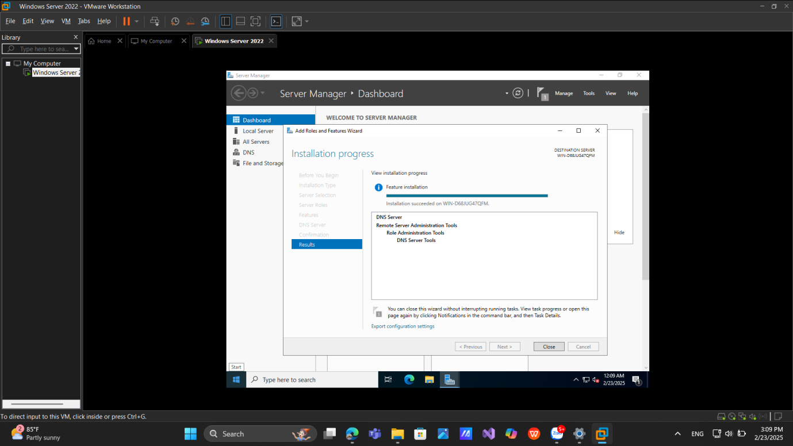**Installing and Configuring the DNS Service**
3. 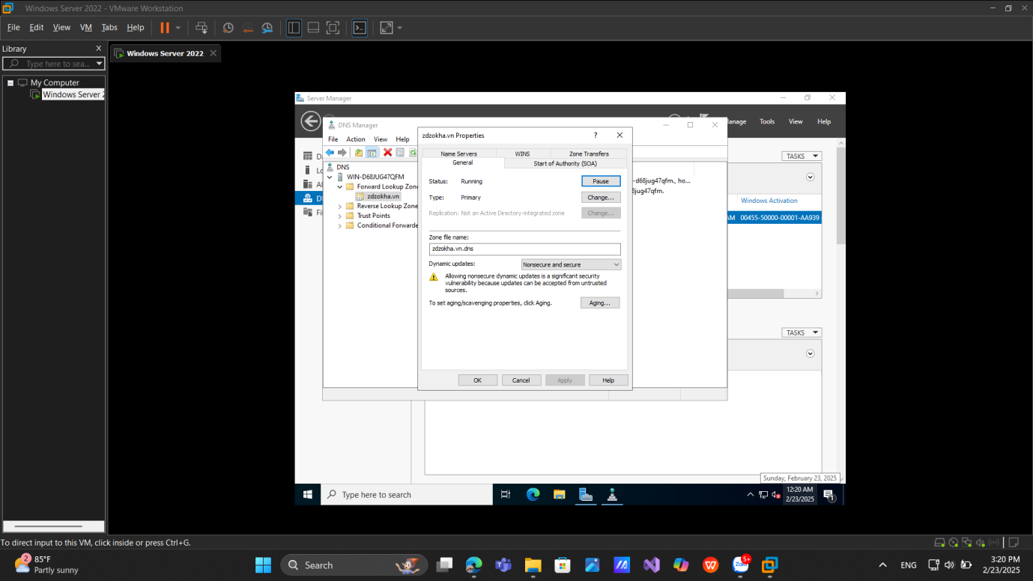**Configuring a Zone for Dynamic Updates**
4. **Creating a Delegated DNS Zone**

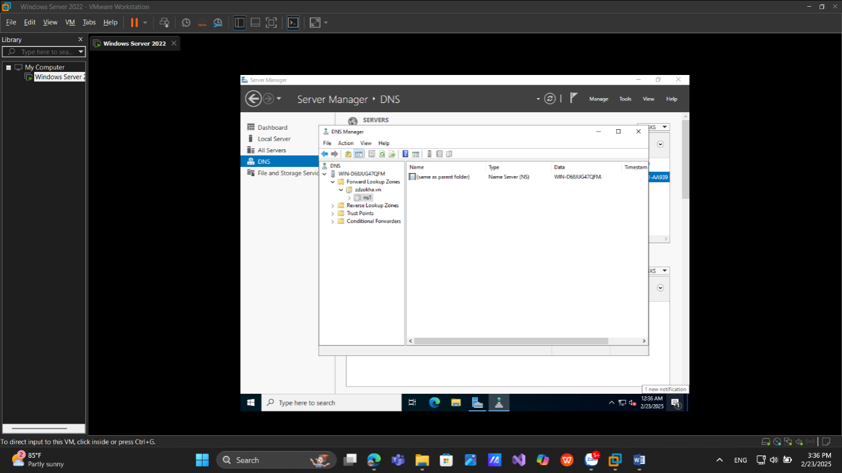

1. **Manually Creating DNS Records**

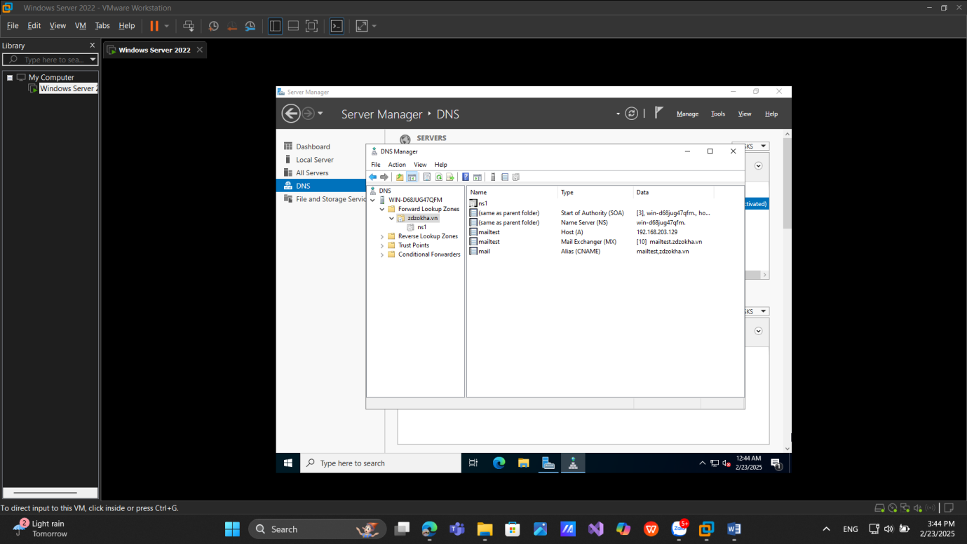

# **2. Active Directory**

**a.** **Promoting a Domain Controller**

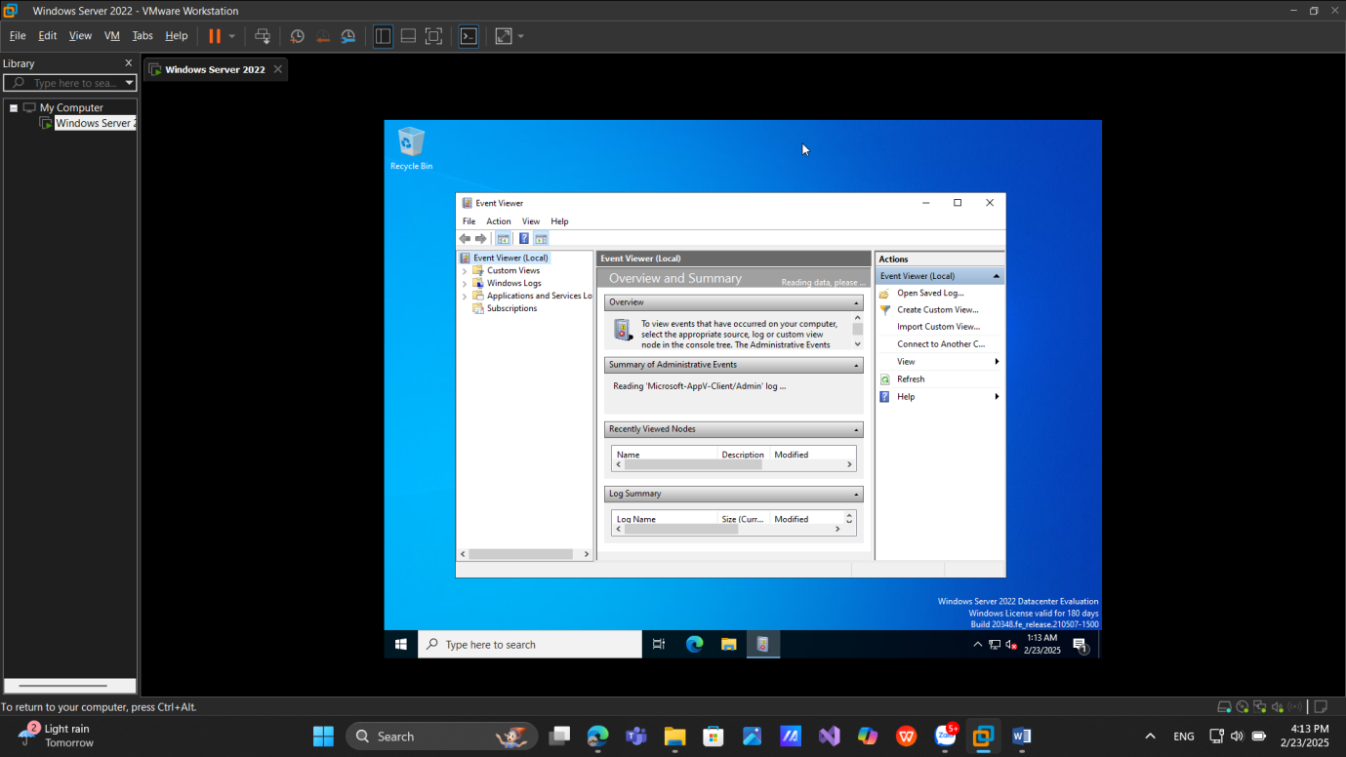

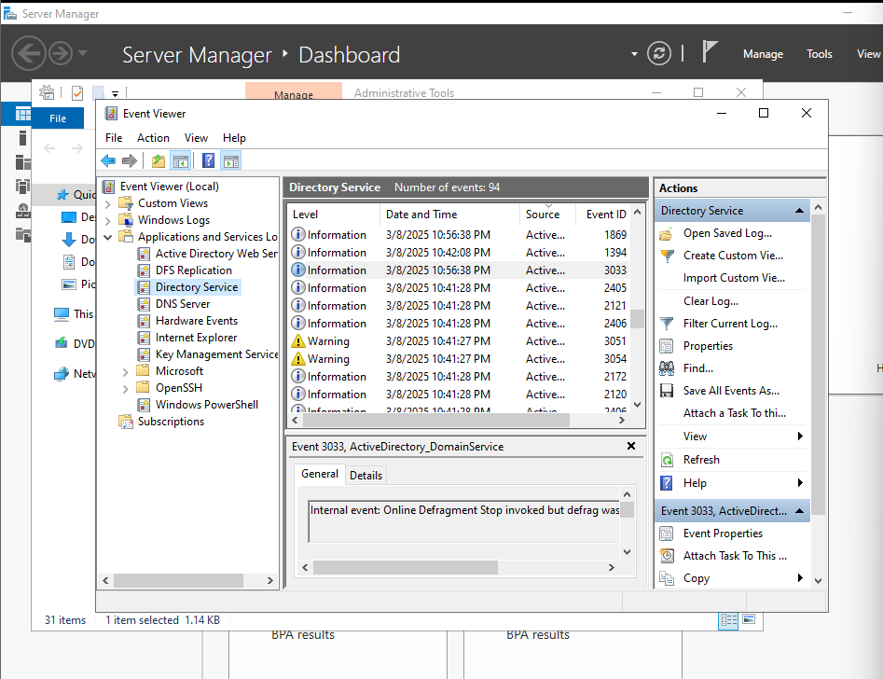**b. Viewing the Active Directory Event Log**

**c. Cài đặt Windows 10:**

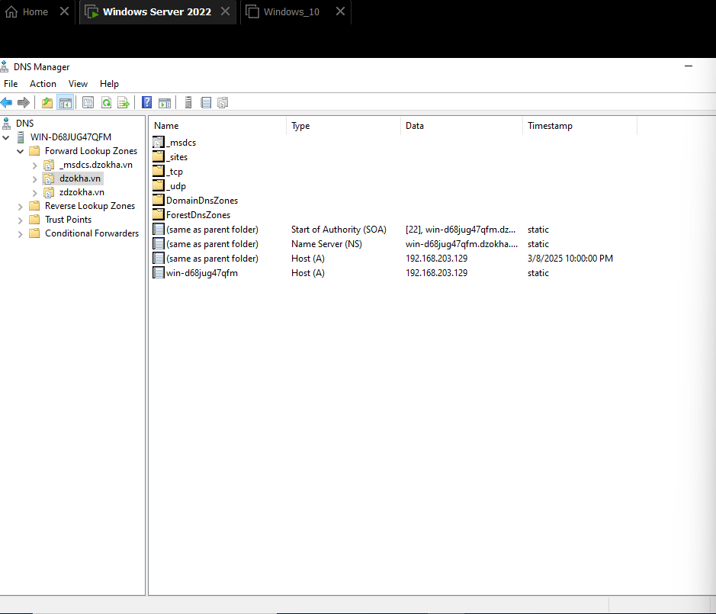**d. Creating an OU Structure**

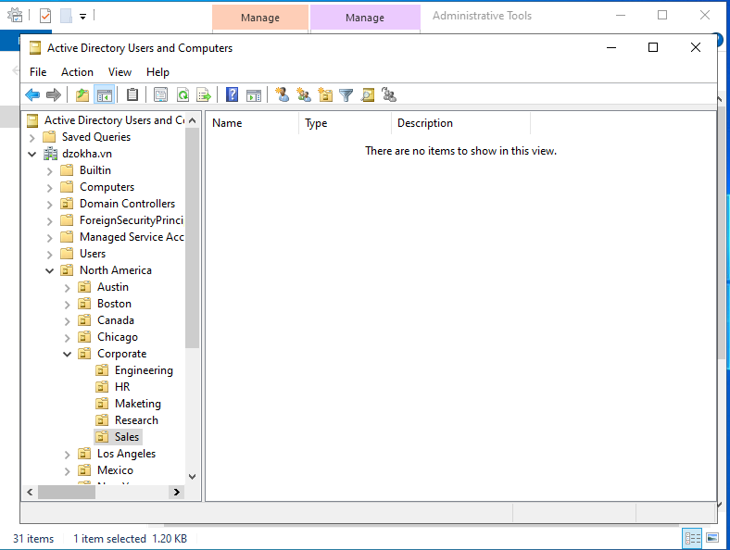

1. **Modifying OU Structure**

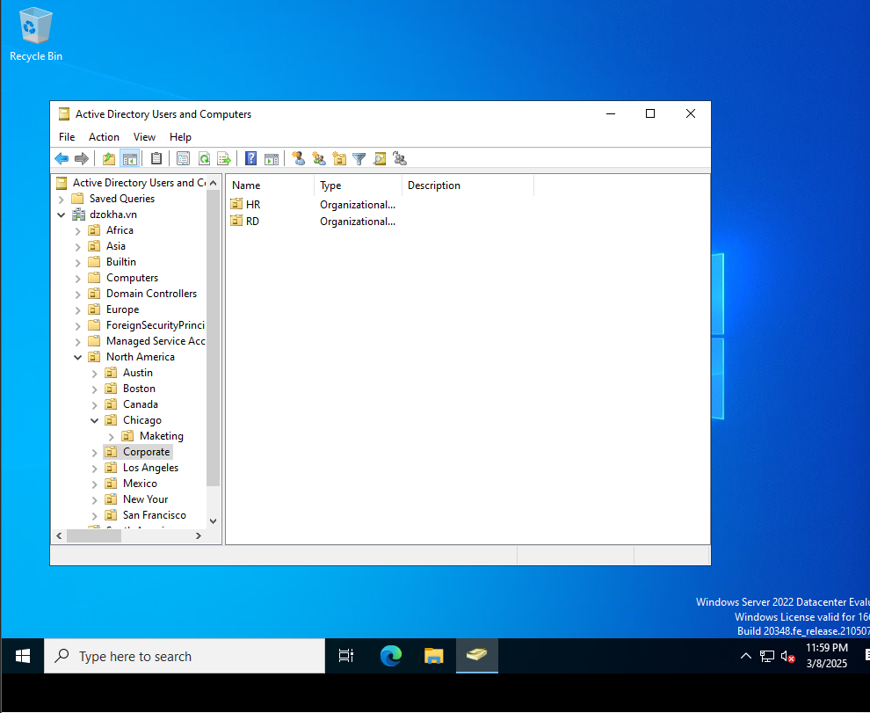

1. **Using the Delegation of Control Wizard**

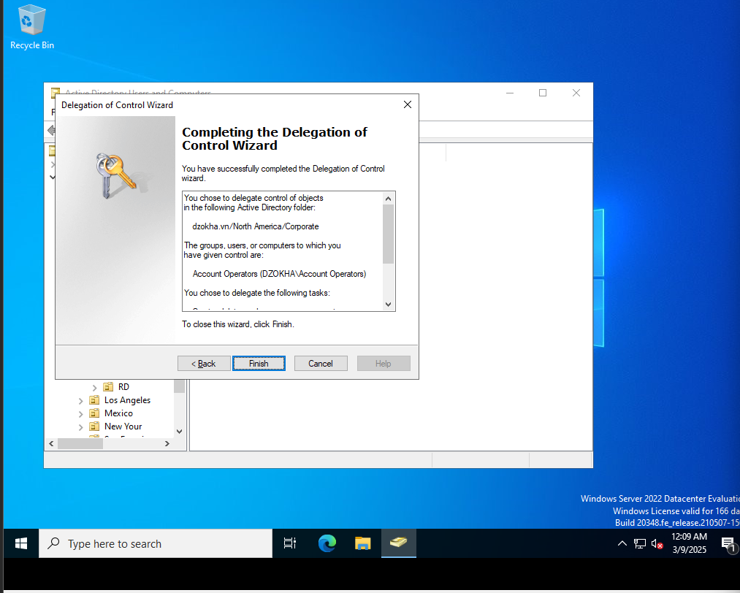

1. **Delegating Custom Tasks**

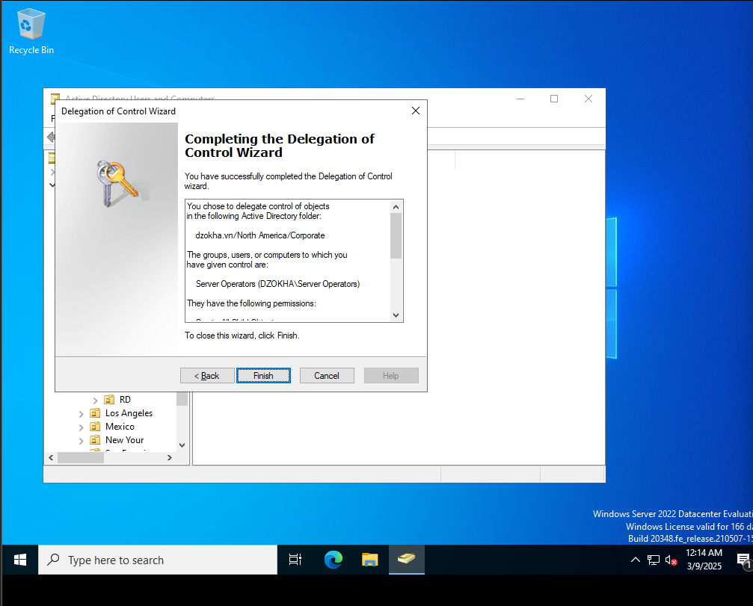

**f. Creating Active Directory Objects**

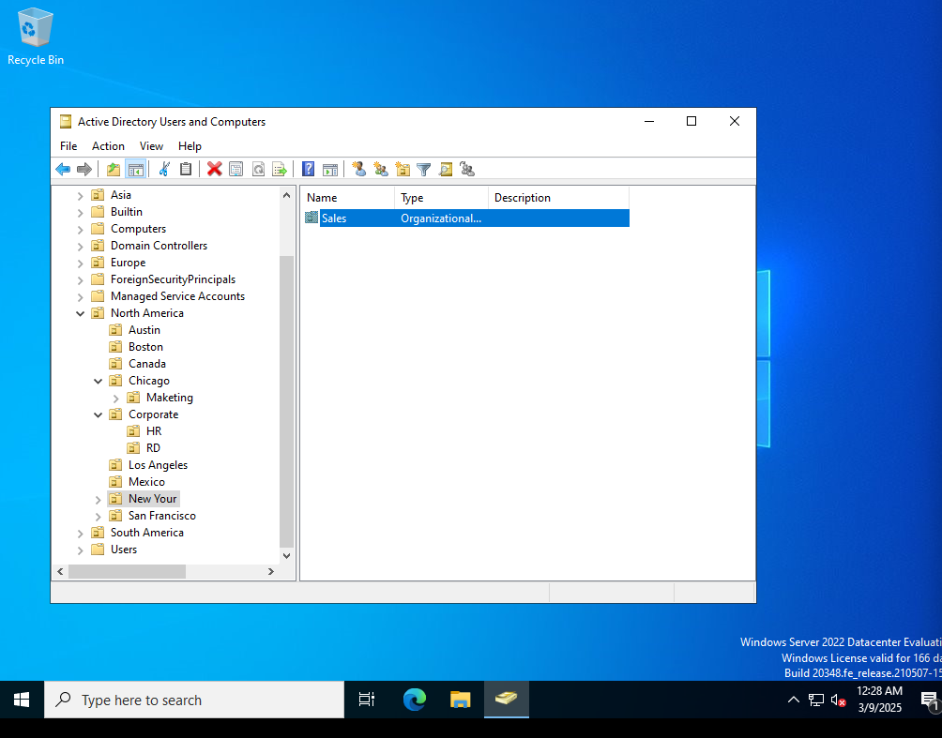

**j. Creating a User Template**

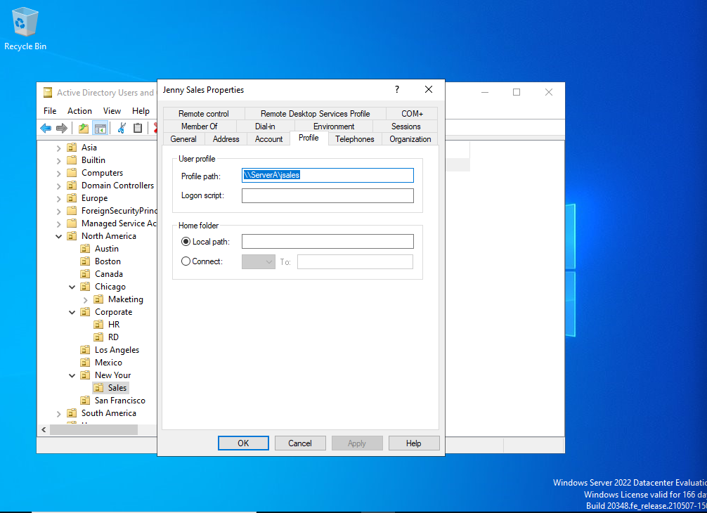

1. **Managing Object Properties**

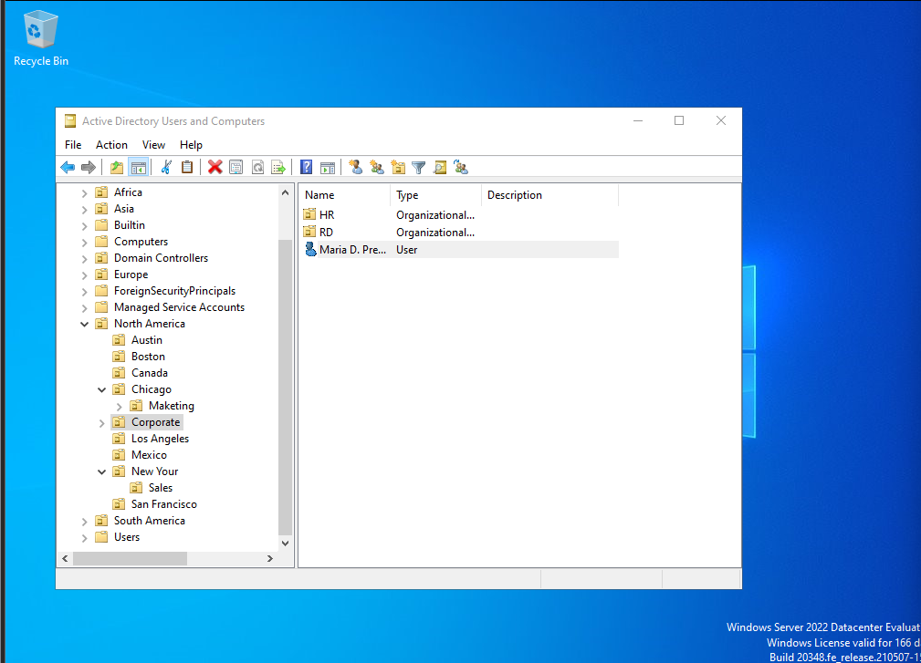

1. **Moving Active Directory Objects**

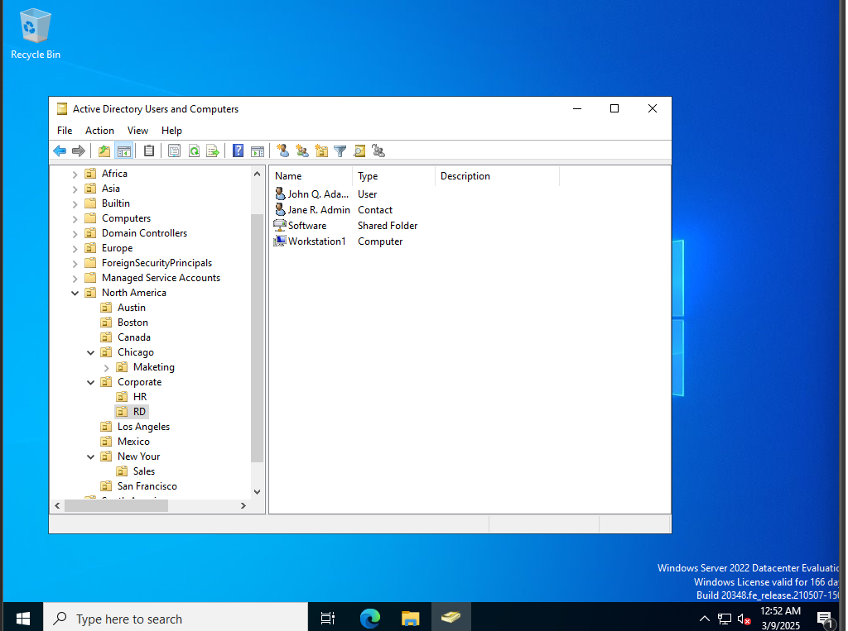

1. **Resetting an Existing Computer Account**

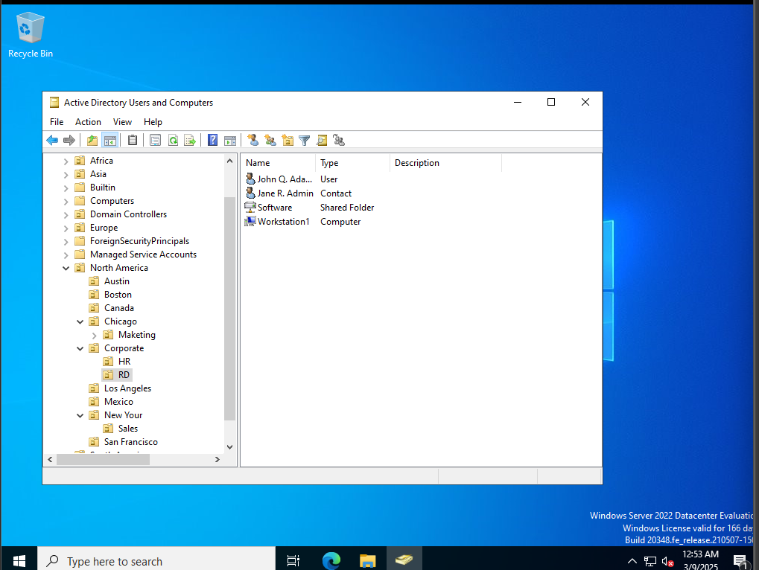

1. **Creating and Publishing a Printer**

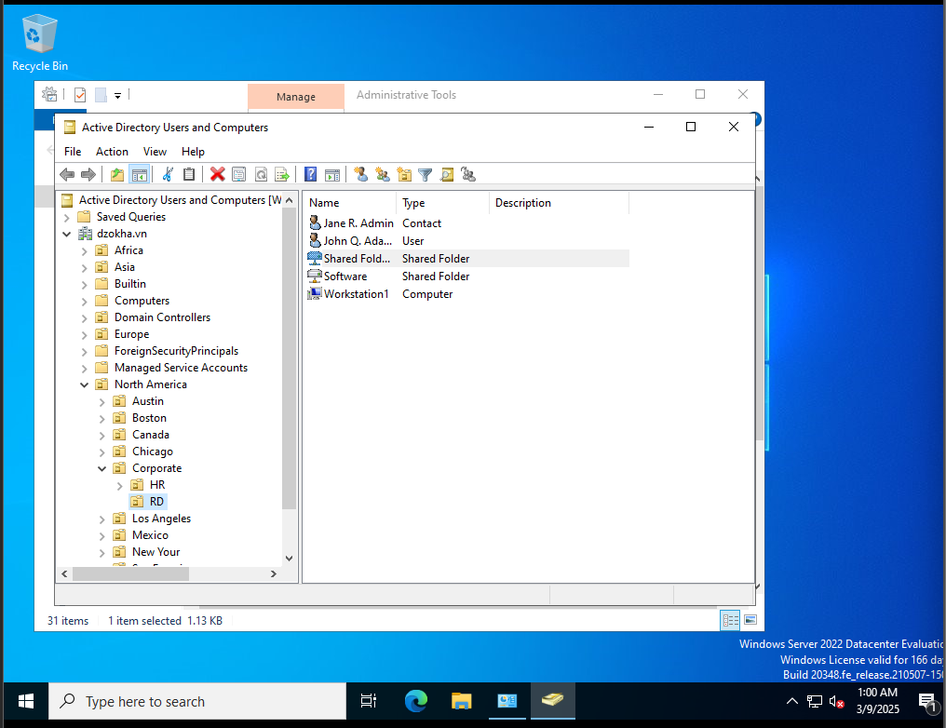

**3.3 Thiết lập DHCP**

**3.3.1. Installing the DHCP Service**

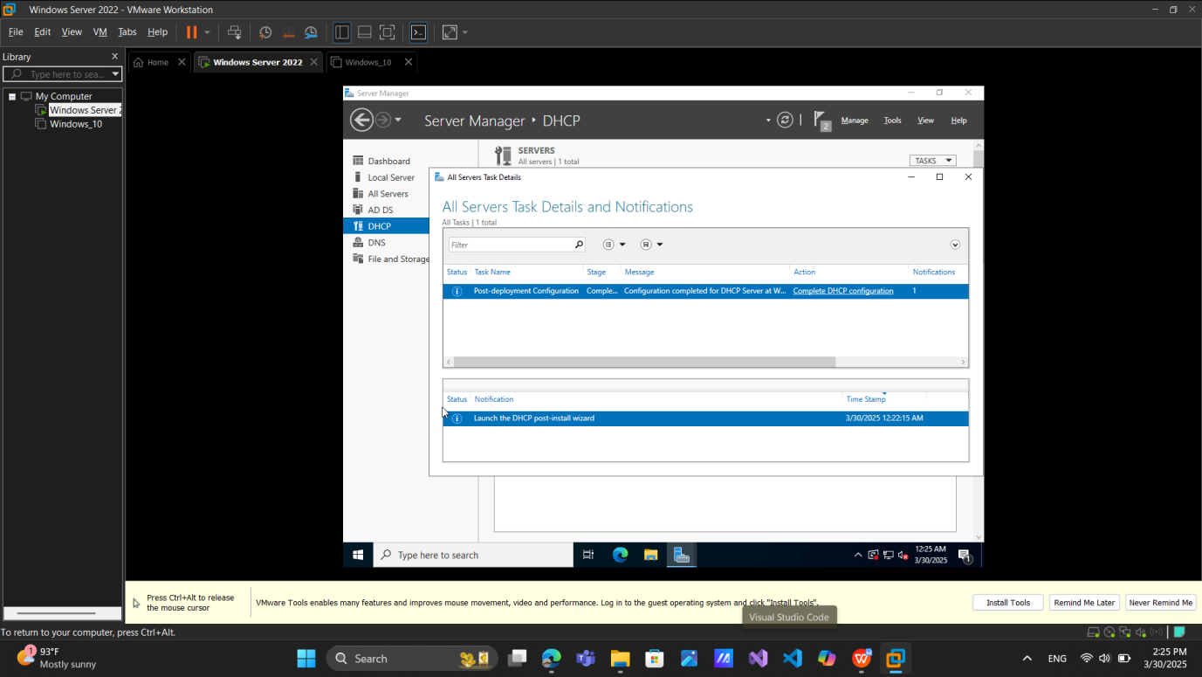

**3.3.2 Authorizing a DHCP Server**

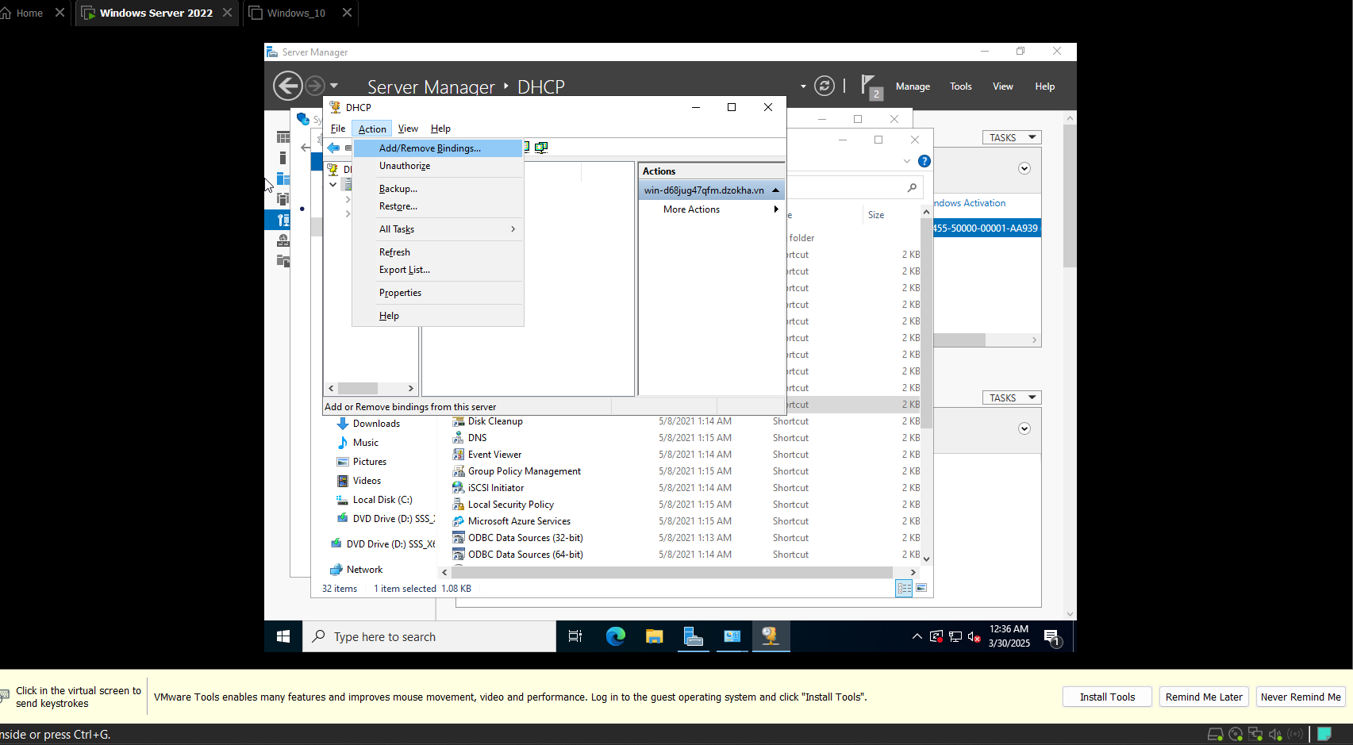

**3.3.3 Unauthorizing a DHCP Server**

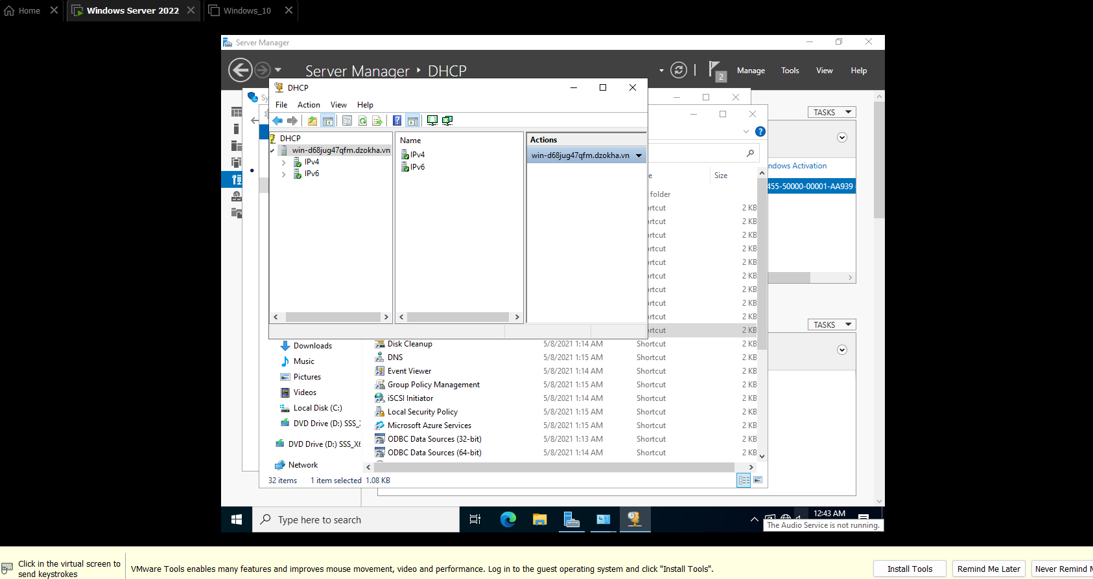

**3.3.4. Creating a New Scope**

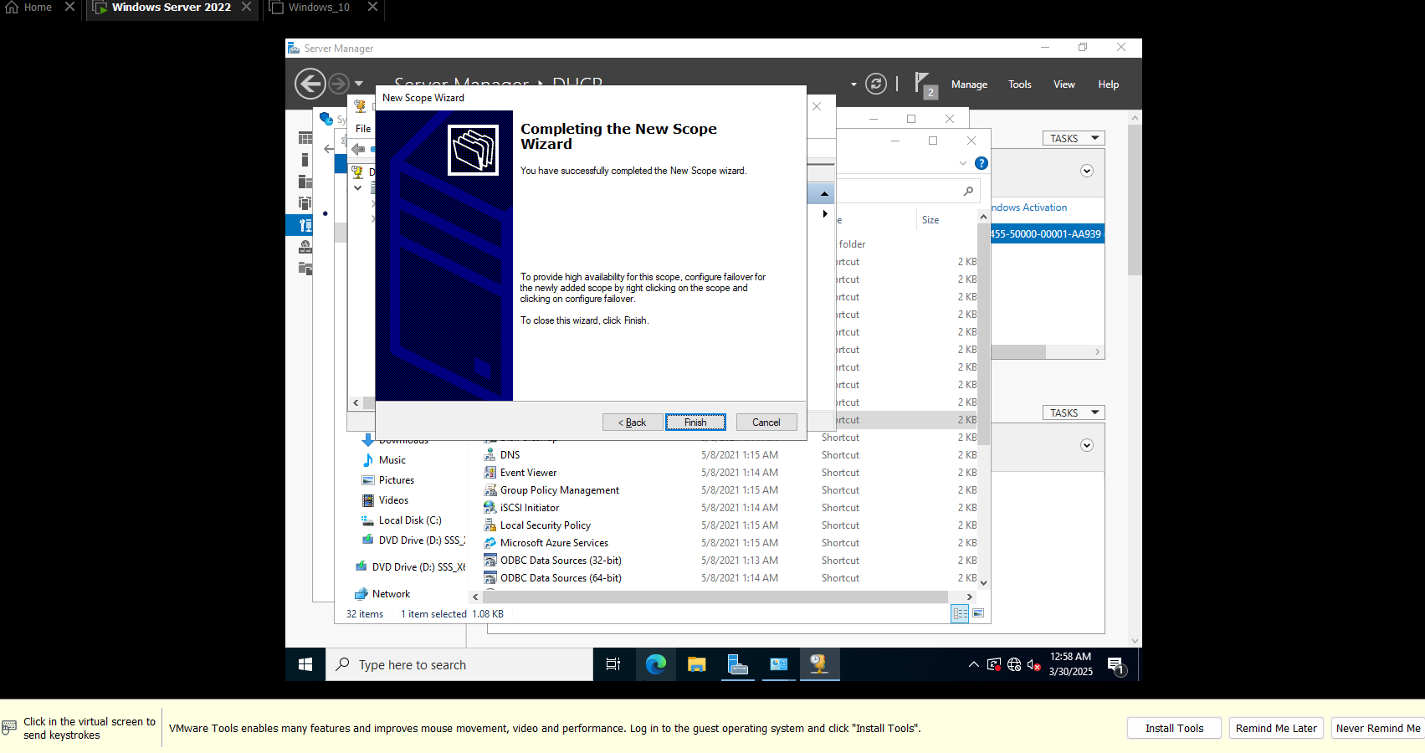

**3.3.5. Creating a Superscope**

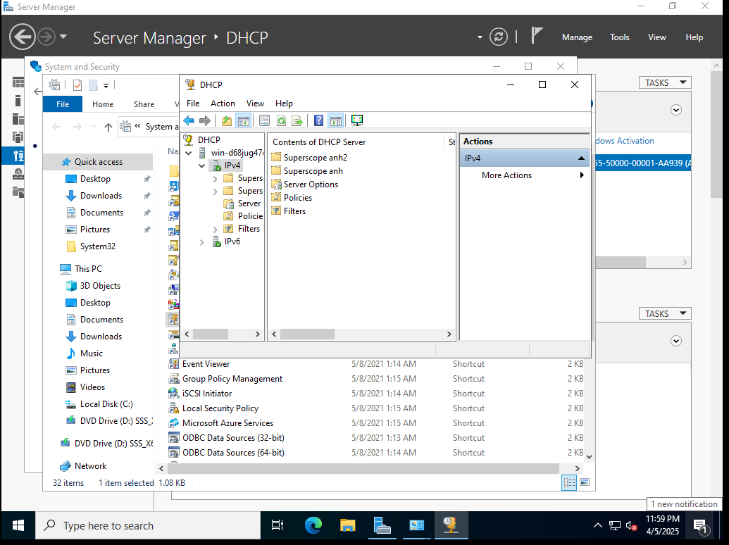

3.3.6. Creating a New Multicast Scope

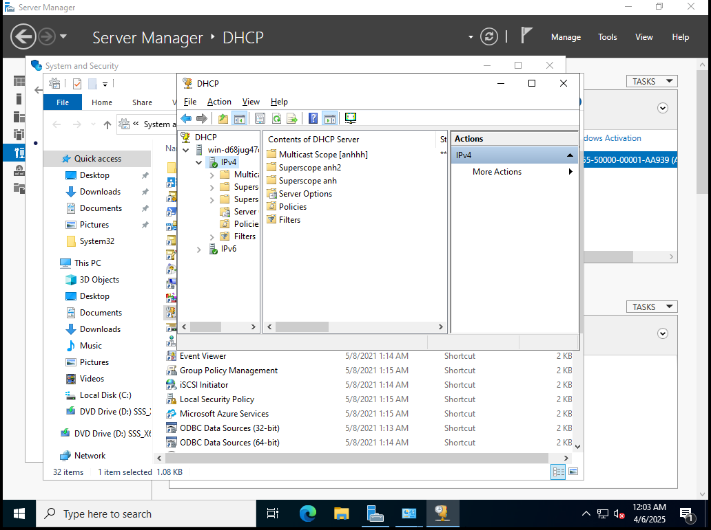

3.3.7. Enabling DHCP-DNS Integration

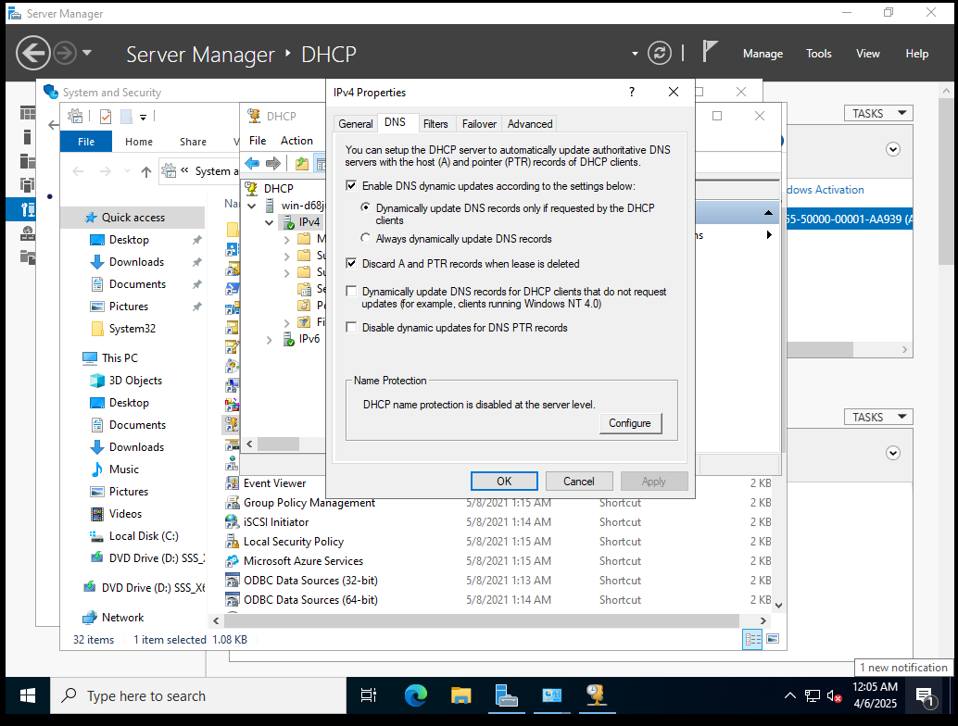

3.3.8. Configuring DHCP Filtering

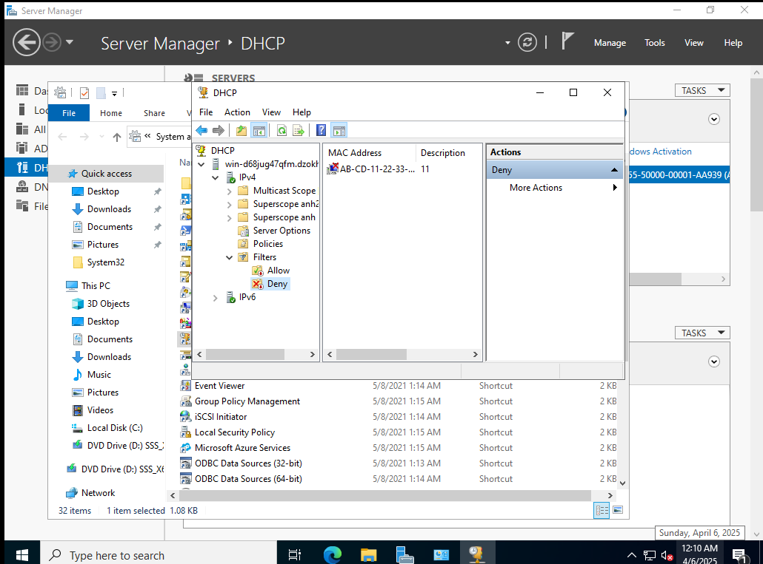

3.3.9. Enabling DHCP Name Protection

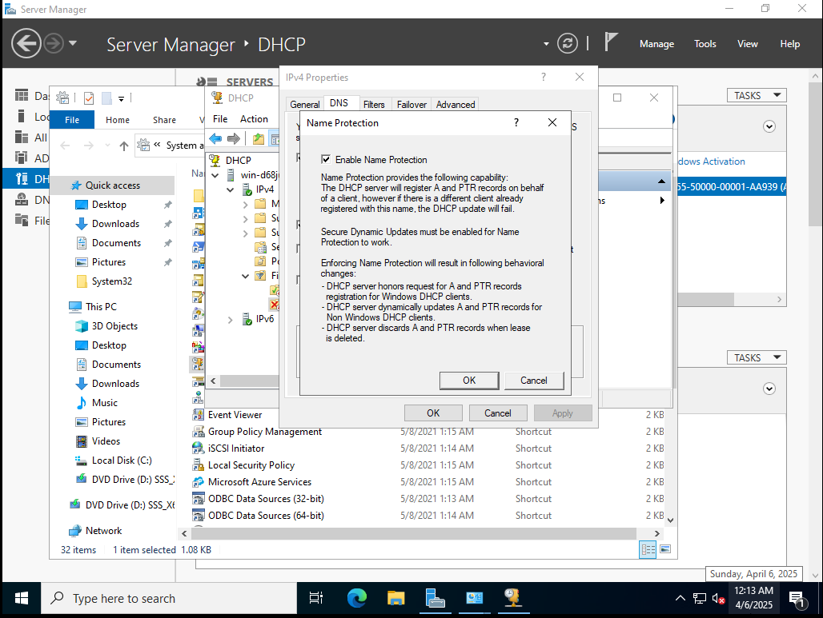

1. **Group Policy**
   1. Creating a Group Policy Object Using the GPMC

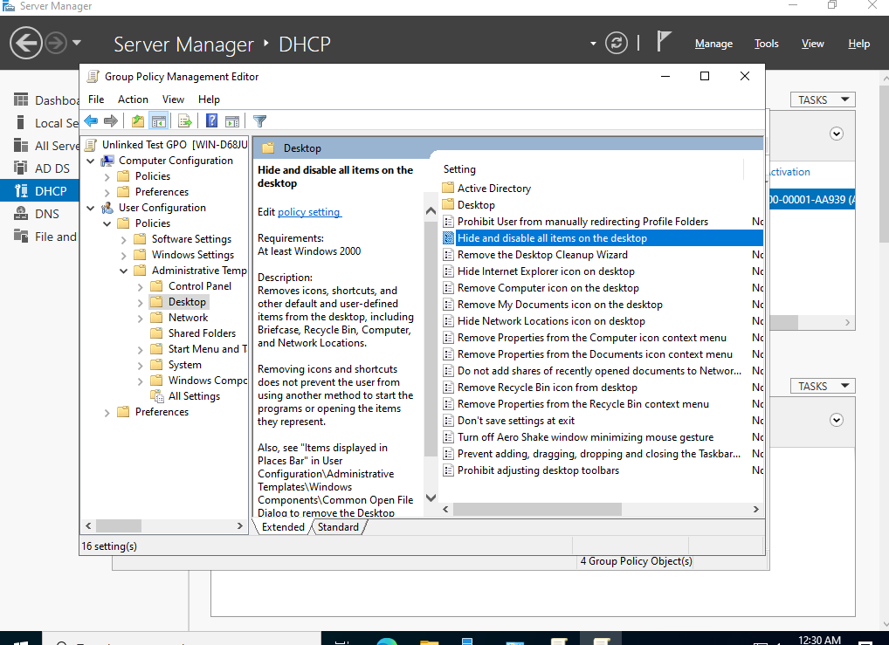

* 1. Linking Existing GPOs to Active Directory

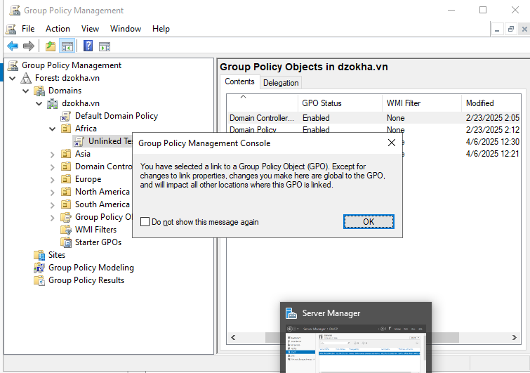

* 1. Filtering Group Policy Using Security Groups

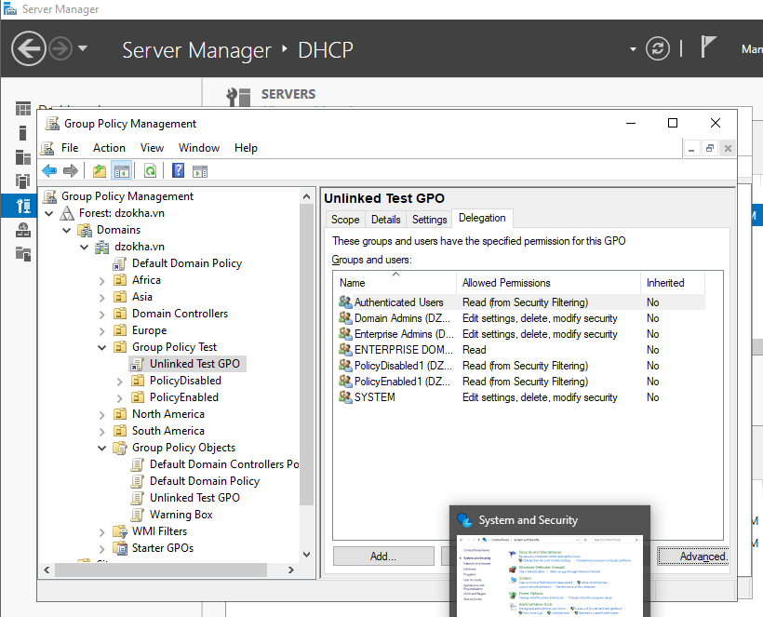

* 1. Delegating Administrative Control of Group Policy

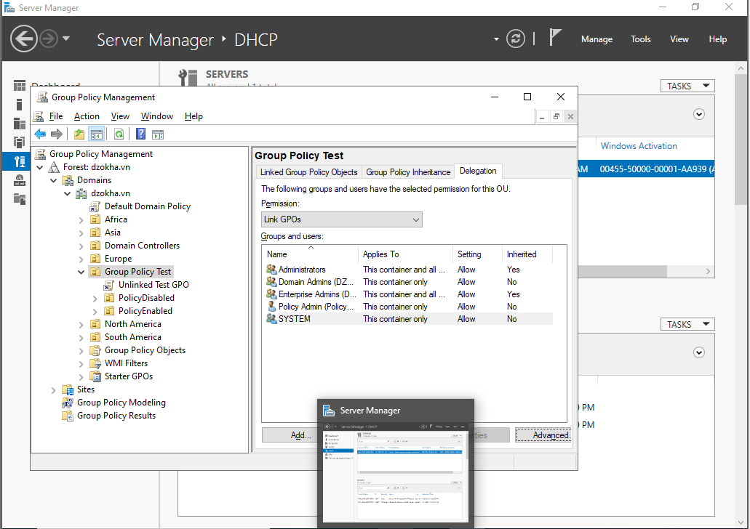

* 1. Configuring Automatic Certificate Enrollment in Group Policy

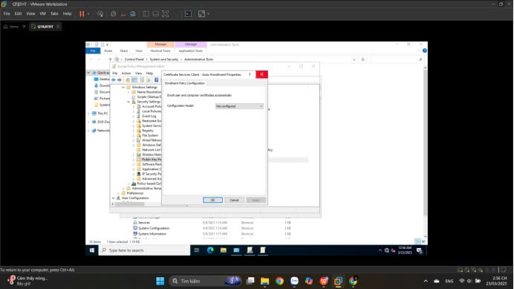

* 1. Configuring Folder Redirection in Group Policy

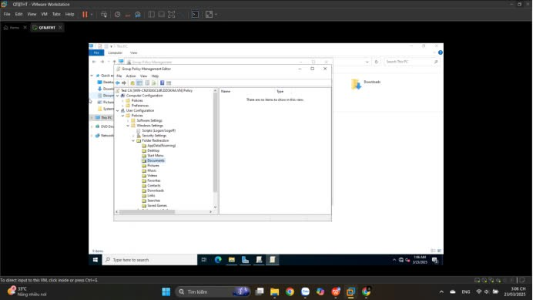

* 1. **Creating a Software Deployment Share**

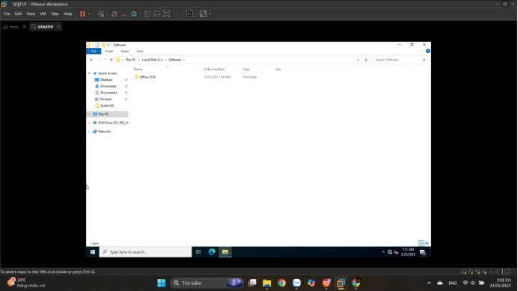

# **Configuring Security**

## **Windows Defender Security Center**

## 

* 1. **Configuring Windows Firewall**

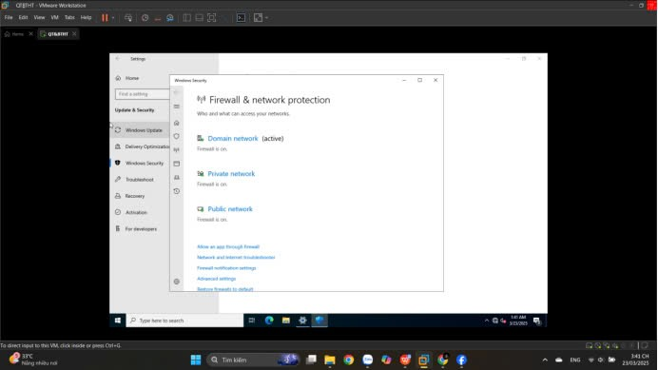

* 1. **Windows Firewall with Advanced Security (WFAS)**

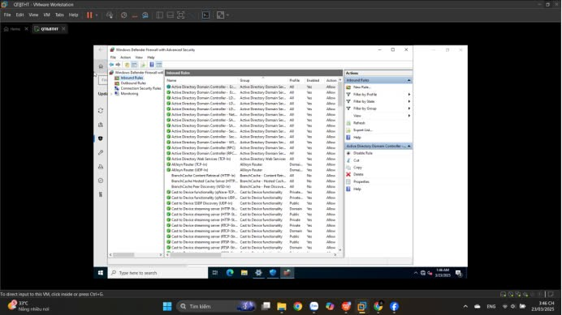

* 1. **Installing Windows Defender Application Guard**

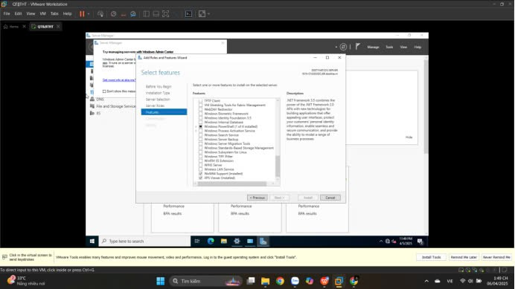

**11.5. Using Windows Defender Application Guard**

**11.6. Windows Defender Application Guard Enterprise**

**11.7. Windows Defender Credential Guard**

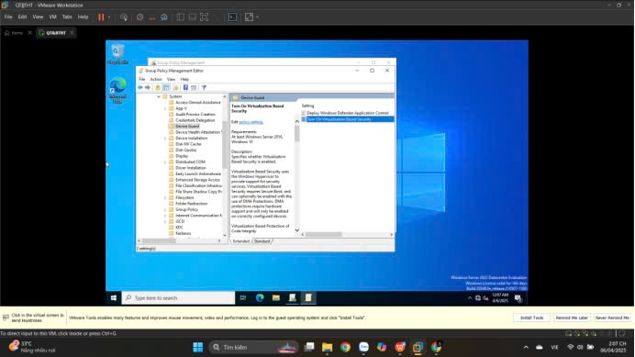

**11.8. Windows Defender Exploit Guard**

